Sudhakar N-Interest Calculation

 User can first select a bank.

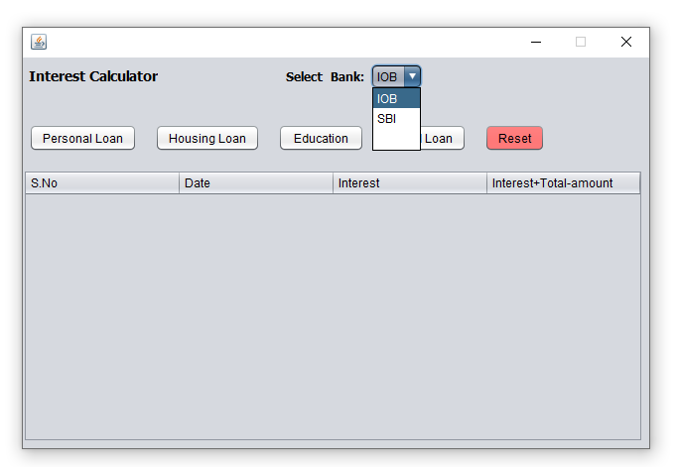

After selecting bank user can select a type of loans like, personal loan, housing loan, educational loan, gold loan.

**Personal loan:**

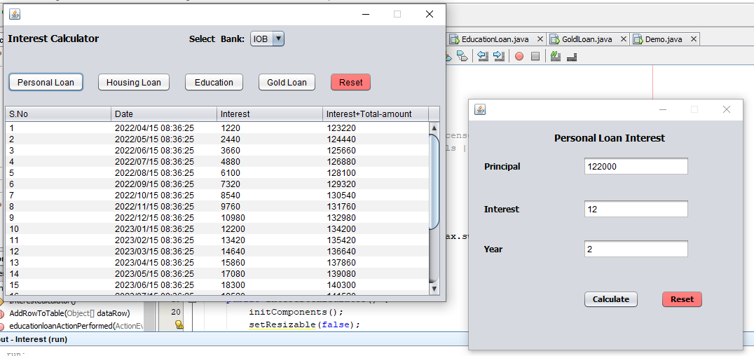

**Housing loan:**

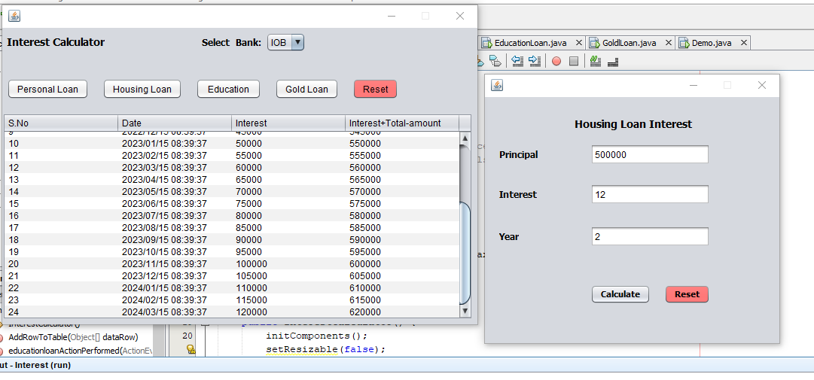

**Educational loan:**

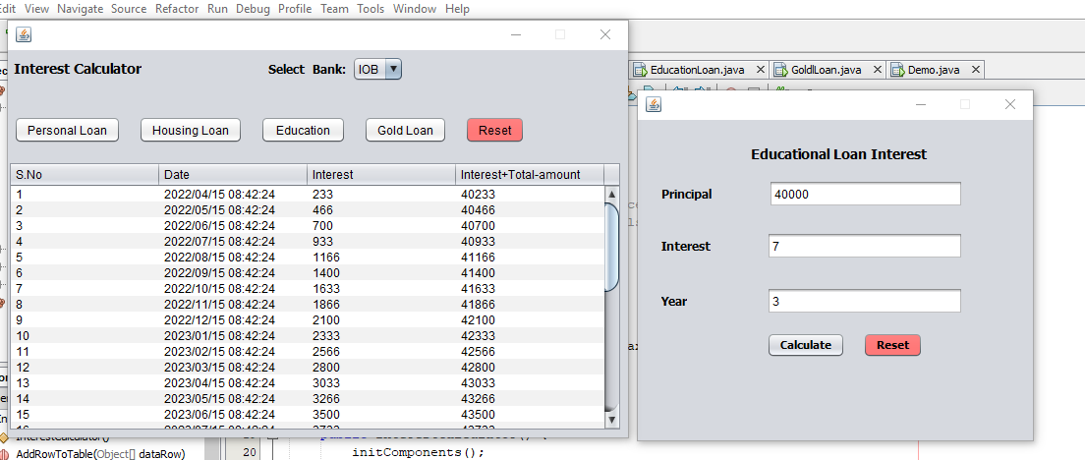

**Gold loan:**